Appendix E: Important Notes on Testing in Firefox

As of this writing, images with alt=””, title=””, or missing both alt and title attributes will result in ANDI Output of “-moz-alt-content” as shown below. This will also be observed if such images are combined with links or other elements.

This image with alt=”” results in ANDI Output of “-moz-alt-content”. However, note that the Accessibility Components section shows that there is alt=”” markup:

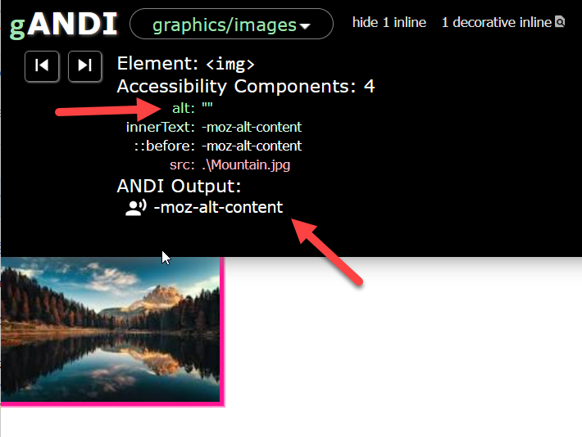

The next image with title=”” results in ANDI Output of “-moz-alt-content”. Similarly, note that the Accessibility Components section shows that there is title=”” markup:

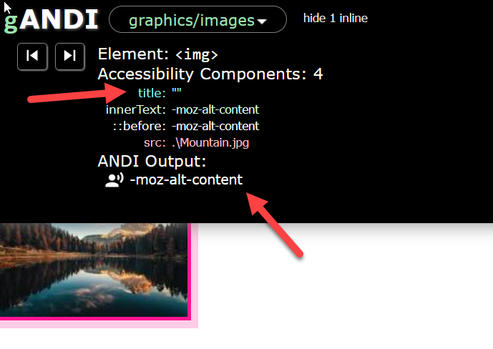

The next image with no alt or title attributes results in ANDI Output of “-moz-alt-content”. Note that the Accessibility Components section shows there is no alt or title markup:

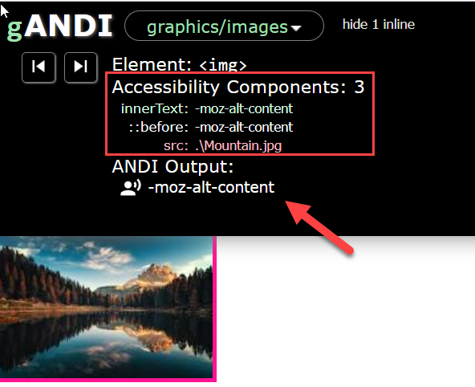

The next image with no alt or title attributes is part of a button and results in ANDI Output of “-moz-alt-content Submit”. Note that the Accessibility Components section shows there is no alt or title markup, but shows the innertext of the button combined with “-moz-alt-content”:

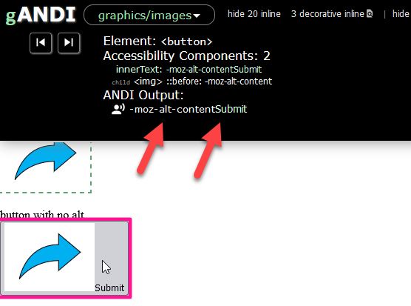

As such, until this issue is resolved, when testing images in Firefox you must modify the test process as follows:

1. If the ANDI Output is ONLY “-moz-alt-content” and no additional text, check the Accessibility Components section.
   1. If there is **no** alt or title markup, this image **FAILS** 7.B.
   2. If there is **alt=”” or title=””** markup, test the image under 7.B. Ignore “-moz-alt-content”.
2. If the ANDI Output is “-moz-alt-content” **along with other text**, ignore “-moz-alt-content”. Evaluate any remaining text under 7.A.
3. When testing focusable elements, links, and buttons, **ignore** “-moz-alt-content” in the ANDI Output. Evaluate any remaining text in the ANDI Output according to the relevant test process.